Predictiveness and Drivers of Avian Influenza Outbreaks in Europe

*Michael Rogo Opata1,2 Andrea Lavarello Schettini1, Jan C. Semenza1, Joacim Rocklöv1,2,3\**

*1. Heidelberg Institute of Global Health, Heidelberg University, Heidelberg, Germany*

*2. Interdisciplinary Centre for Scientific Computing, Heidelberg University, Heidelberg, Germany*

*3. Department of Public Health and Clinical Medicine, Section of Sustainable Health, Umeå University, Sweden*

*\*Corresponding author : Interdisciplinary Center for Scientific Computing, Heidelberg University, Im Neuenheimer Feld 205, D-69120 Heidelberg, Germany.*

*E-mail :* [*joacim.rockloev@iwr.uni-heidelberg.de*](mailto:joacim.rockloev@iwr.uni-heidelberg.de)*, Heidelberg University, Im Neuenheimer Feld 205, 69120 Heidelberg, Germany*

# **Abstract**

Avian Influenza virus (AIV) outbreaks are on an increasing trajectory. These outbreaks carry a substantial economic burden, resulting in considerable losses to farmers with profound impacts on economies. As the outbreaks continue in birds and other unusual host species, further virus evolution and spillover to humans’ risk is anticipated to grow and potentially involve into new pandemics. Despite this, the underlying drivers of the outbreaks remain elusive. We develop machine learning models capable of predicting AIV events in Europe dynamically uncovering the critical determinants of the outbreaks. Temperature, water index, and vegetation index, and infected wild birds play pivotal roles, with the importance coming into play at different times of the year. Combining these drivers, the outbreak pattern is predicted with an accuracy of 94%. These insights lay a robust foundation for elucidating the intricate landscape of AIV outbreaks, offering valuable insights for proactive preventive interventions to mitigate spillover.

# **Introduction**

The contribution of eco-climatic drivers to human disease has been known since time immemorial.1 This concept also holds true for animal diseases and is fundamental for the understanding of disease emergence and spread. It has become even more apparent in the wake of the recent COVID 19 pandemic which involved the emergence and dispersion of SARS-CoV-2.2 Other respiratory diseases which pose potential risk of spill-over and spread among human beings are those caused by avian influenza viruses (AIVs) via subtypes H7N7 virus transmitted through contact with infected poultry.3 There is an increasing concern of such events expanding into a pandemic; therefore, attention has shifted to active surveillance and detection of these outbreaks in several parts of the world involving not only wild and domestic birds, but also increasingly other mammalian hosts. 4–8 The latest major poultry outbreak occurred between January 2022 and early 2023 with most events reported from the Global North.9

There are four types of AIVs namely, type *A, B, C* and D. The H5N1 subtype belonging to type A *Influenza virus* is the highly pathogenic variant of the existing types of AIVs and is commonly hosted in Ducks, shorebirds, gulls and other waterbirds, naturally *Anseriformes* and *Chadriiformes*.10 The relationship between these bird hosts and their surrounding ecology plays a critical role in the biology of the disease. Existing evidence alludes to the fact that pathogenic strains are primarily perpetuated through host-to-host transmission during fledging and nesting at water sites.11 A long-term debate has also existed on how migratory birds contribute to the spread of the viruses across regions especially between the Eurasia and Europe.12

Sporadic AIV infections between mammals have also been reported since 20039 and have been increasingly reported during the latest epidemic wave in wild terrestrial and aquatic mammals, and more recently, in domestic animals, including pets.13–16 These reports generally coincide with disease events in wild birds as well as poultry and could occur when predating mammals presumably eat infected birds.17,18 Of course, such a complex mechanism occurs within a shared environment between involved species and is often thought to be driven by various factors including climate variability and change, migration, predatory behavior etc. Since human beings exist in this nexus, the potential spillover of these highly pathogenic viruses is not far-fetched considering increased interactions with other susceptible species.19

When AIV outbreaks are detected in animals, Member Countries of the World Organisation for Animal Health (WOAH) are obliged to report them immediately through the World Animal Health Information System (WAHIS).20 This comprehensive database contains useful spatial-temporal information about several animal disease outbreaks captured since 2005 to date. Figure 1 summarizes the European annual AIVs outbreaks reported through WAHIS. This includes events involving both High and Low Pathogenicity Avian Influenza viruses in poultry and non-poultry. There was a significant surge in reported cases between 2016 and 2017. In contrast, 2018 and 2019 witnessed a remarkably low incidence of outbreaks, followed by a sudden and pronounced upswing in cases during 2020 and 2021. The discernible oscillation in these outbreaks underscores the need for a comprehensive study to examine the patterns and potential factors that contribute to the spread of AIVs.

Epidemiology has seen a steady increase in the use of prediction models for early warning systems.21 For AIV outbreaks, the distance to coastline, distance to wetlands and AIV in wild birds have been used as predictors both on a country scale for Denmark22 and European scale.23 The association between AIV outbreaks and distance to migratory waterfowl sites, distance to major roads and distance to rivers has also been explored in Romania.24 In California,25 land cover and distance to coast were predictors of AIV outbreaks. Surface water and domestic bird density were associated with seasonal clustering of AIV outbreaks in domestic poultry in Africa, Europe and Asia using models of landscape epidemiology.26 Similarly on a country level, bird density and landscape variables were predictors of AIV outbreaks in the Netherlands. 27

These tools aid in better understanding of the underlying and sometimes hidden patterns contributing to unexpected outbreaks. If responses are deployed in a timely manner, the adverse economic impact associated with such events could be averted.28 In the context of AIV, some studies have carried out assessment of outbreaks and the drivers thereof involved in the wild bird-poultry interface.29–31 To the best of our knowledge, our study is the first to carry out comprehensive predictive study at a high geo-spatial resolution in Europe.

In this paper, we create explainable and predictive models using machine learning (ML) to study how eco-climatic, social-economic and infected wild birds predict and explain the outbreaks of AIV in poultry and their predictive accuracy. For this, we use data from a variety of sources describing the development in Europe between the years 2006 and 2021. We specifically investigate if eco-climatic and socio-economic variables predict AIV outbreaks as the nature of the association; the importance of time-varying variables change with season and variable interactions; what species of wild birds are most predictive of poultry outbreak events; and, what variable composition provides the most accurate predictions on data withheld from model fitting.

Figure 1: AIV distribution and number of outbreaks in Europe between 2006 and 2020(left). The middle map shows the 2021 AIV outbreak distribution and intensity. The right figure shows a timeseries of Avian Influenza outbreaks between the years 2006 to 2021(right). These figures reflect the statistical aggregation for the European region as defined before the United Kingdom exited the European Union. The data consists of domesticated poultry, wild birds, and other mammalian species from WOAH (ref =20).

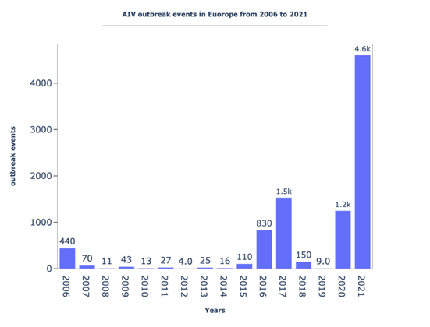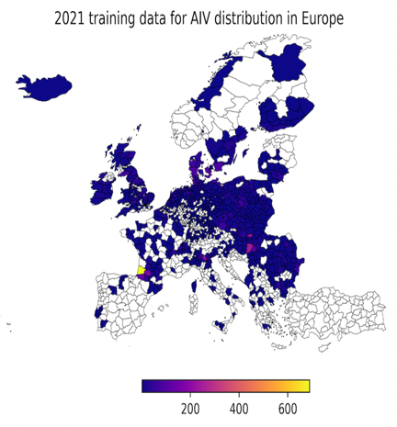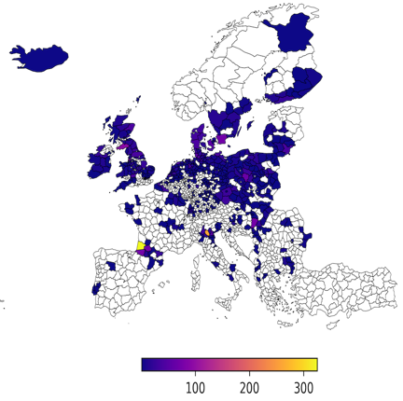

# **Methodology**

**Data Collection**

The data used in this study were obtained from WAHIS. In WAHIS, each event is composed by one or more epidemiologically related outbreak, as assessed by the national veterinary authorities. An outbreak, as defined by the WOAH Terrestrial Animal Health Code, is the occurrence of one or more cases within an epidemiological unit, which in turn can be understood as a group of animals with a defined epidemiological relationship that share approximately the same likelihood of exposure to a pathogenic agent. We included all outbreaks of poultry, wild birds, as well as mammalian species reported by European countries between 2006 and 2021 (Figure 1). The point dataset was aggregated at an annual time scale and geocoded into their respective NUTS3 (Nomenclature of territorial units for statistics) regions for mapping onto other variables.

Eco-climatic variables i.e., the temperature and rainfall together with high and low vegetation indices were obtained from the Copernicus Climate Change Service (C3S, https://climate.copernicus.eu/the-climate-data-store). The Normalized difference water index (NDWI) and Normalized difference vegetation index (NDVI) were obtained from Landsat 8 Collection Tier 1 and MODIS/Terra Vegetation Indices dataset respectively.32–34 Additional socio-demographic and economic data i.e., the male and female population density, Gross Domestic Production (GDP), and annual trading variables was obtained from the Eurostat database.36

Bioclimatic variables (*bio1-bio19*) were included to capture seasonality and complex feature interactions between wild-bird outbreaks and eco-climatic drivers of host-virus amplification and the suitability of geographical introduction (See SI Table 2 for details).37 A further processing of the explanatory features was employed by using wild bird species to predict the poultry outbreaks. Our hypothesis emanates from the fact that in a typical disease event, it is widely observed that milder infections in wild birds tend to cause severe symptoms in domesticated species.28 With these features at hand, we constructed the models to evaluate the accuracy of predicting AIV outbreaks. The dataset was split into three parts. The training data was taken from the year 2006 up to the year 2020. The 2021 data was further split into two parts: validation dataset and test dataset. This split was achieved by randomly selecting data points at a ratio of 80 to 20 for validation and test respectively.

**Model assessment, selection, and evaluation**

Classification tasks can be carried out using various machine learning algorithms such as logistic regression, classification trees, gradient boosted trees methods, and random forest.38 We employ the XGBoost algorithm which is a subset of the gradient boosted tree family and is known to perform well in general classification studies. The model’s parameters were tuned before construction and the resulting optimal values used for consequent model runs.

Each model was constructed from different engineered features and their targets based on the specific question of interest. Features were categorized into climate, environmental, demographic, economic, bioclimatic, birds and trade classes. The climate variables were aggregated into quarters to match the seasonality in Europe, i.e., quarters one (Q1), two (Q2), three (Q3), and four (Q4) correspond to January-March, April-July, August-October, and September-December respectively. A total of three models were constructed (See Table SI 3). Model 1 (M1) consisted of 49 features and was used to answer a general question; what eco-climatic and socio-economic variables drive AIV outbreaks and how predictive are they? In this model, temperature and rainfall variables for all quarters and other categories were included. In Model 2 (M2), wild infected bird features were introduced additionally (totaling 259 features), and the model was designed to answer the question; how do wild bird outbreaks in combination with eco-climatic and socio-economic drivers affect domesticated bird outbreaks? In the final model (M3), the wild birds were used as features to predict domestic bird outbreaks while simultaneously disabling their targets. The goal of the last two models was to investigate the role and predictive gain from having wild bird outbreak surveillance data. Furthermore, these two models were used to identify which bird species play a critical role in AIV spread. Biologically, it is known that mild wild bird AIV strains sometimes cause severe outbreaks in poultry whenever spillover events arise.10,28 In that respect, we aim to study the on and off influence of this phenomena by tweaking the targets of the wild birds when used as features.

Simultaneous evaluation of the models was carried out using a combination of the *logloss*, the receiver operating characteristic curves (ROC), and estimates of the area under the curve (AUC) evaluation metrics. The respective cross-validation *logloss* and the models’ *logloss* were plotted. While these plots are plausible, interpreting the significance of the models’ results is not straight forward. Local Interpretable Model-Agonistic Explanations (LIME)39 and SHapely Additive exPlanations (SHAP)40 are two explainable constructs that can be used to complement the interpretation of a ML model. These methods simplify the global complexity in the model and approximate it around the vicinity of instances where the optimization of the resultant model is always treated as a submodular problem. SHAP uses additive feature attribution formulation to break down individual contribution of each feature whose impact is easy to explain.

XGBoost seamlessly integrates with the SHAP library to provide ranked important features influencing the prediction of a model. Features with high impact on the outbreak prediction were characterized for each constructed model. An aggregation based on individual contributions yielded percentages used to assess the overall important drivers. Additionally, key interactions of highly correlated variables highlighting important interplay between wild birds, climate and environment were also analyzed.

# **Results**

We devised a gradient-boosted tree model, based on the XGBoost algorithm, to disentangle the individual contribution of different drivers of AIV outbreaks between 2006 and 2021 in Europe, at a high spatiotemporal resolution. We tested a wide range of explanatory variables of these AIV outbreaks, including climatic, environmental, socio-economic, human population density, and ornithological variables. The three different models subjected to validation with out-of-sample data revealed high predictive accuracy of the spatiotemporal dynamics of AIV outbreaks among poultry. Based on the logloss evaluation metrics on the test-dataset, M1 had a value of 0.14. On the inclusion of wild bird species as features in M2, the predictive ability of AIV outbreaks was more robust with a drastic shift to 0.08 (Figure 2). Disabling the wild bird labels on the other hand results in an increase in logloss for M3 to a value of 0.12. Consequently, the AUC scores for M1, M2, and M3 were 0.921, 0.942, and 0.941 at (95% CI) respectively. The true positive rate was 97.55, 97.64 and 98.94 while the true negative rate was 86.79, 90.73 and 89.53 respectively for M1, M2 and M3. M2 therefore emerges to be the optimal model in predicting AIV outbreaks. The above results were obtained using a baseline threshold of 0.5. For brevity, we computed performance metrics at thresholds 0.1, 0.2, 0.3, and 0.4 to gain insights on the extent of specificity and sensitivity changes with threshold shifts (SI Table 3). The outstanding sensitivity and response prediction of M2 led to its choice as our favorable model for result presentation and discussion. It is hereafter referred to as the model. The results and discussions for models M1 and M3 are provided in the Supplementary Information.

Figure 2: Values of the Logloss Evaluation metric for all models on the validation dataset (2021) and test (2021) dataset. The model M2 performs better compared to M1 and M3 on the test dataset. A separation of the performance on the validation dataset differs as one moves from M1 to M3, while on the test-dataset the minimum is observed for model M2.

**Key drivers of AIV outbreaks**

A range of features are found important for predicting AIV in M2 (*Figure 3*). Among those, climatic and bioclimatic variables rank the highest importance, followed by environmental and vegetation factors, and socio-economic factors, such as trade and demographic conditions, followed by wild bird outbreaks in white swans (*Cygnus olor*), and finally by more general socioeconomic conditions (GDP and population density). The relationship between these variables and the occurrence of outbreaks in poultry is, however, complex and, for example, show non-linear, U-shaped patterns in relationship to temperature. We observed a strong binary spike pattern in the SHap value in relationship to *Cygnus olor*.

The top global ranking features in the model reveal that colder temperatures (min_temp_q3) in the Fall is the most important predictor with a U-shaped pattern where for some regions, the effect of low and high values decrease and increases the prediction. Additionally, the mean temperature (mean_temp_q2) in Spring also plays a critical role. Here, low values have negative impact on the model. These climate variables might have behavioral implications for the birds but might also affect the environmental fate of the virus, in that colder temperatures are more permissive for viral survival. We capture these possible implications in the form of the minimum temperature of the coldest month (bio-6), normalized difference vegetation- and water indices. Bio6 has a positive impact on the model resulting in the positive outbreaks prediction. During winter, low availability of water as well as vegetation signifies low risk of outbreaks. These both variables play a significant role as natural habitats to the main culprits (*Cygnus olor*) which are known to migrate during winter. Wild bird features tend to increase the influence of temperature in comparison to M1 and M3 (see Figure SI 2). The cumulative significance of wild bird SHAP values ranks fourth among all the categories for M2 highlighting their overall important role in AIV transmission dynamics. The specific wild bird internal ranking in terms of family order is presented in *Figure 4*. The trade variable (Unloading) also appears among the top 6 ranked features pushing the model towards predicting low cases as low trade volumes translate to low imported cases. This effect has been reported in large economies where increased trade is known to facilitate efficient and rapid AIV transmissions.41 In general, temperature, water index, vegetation index, wild birds, trade, and bio6 play a critical role in influenza outbreaks according to our model which captures dependence on the first and second quarters of the year.

An overview of the categories consisting of aggregated features derived from SHAP values (Figure SI 3) show climate ranks as a top influencer of AIV outbreaks, followed by environment and bioclimatic variables respectively. The infected and detected wild birds also play a significant role in the transmission dynamics and cumulatively ranks above trade and economic classes.

We provide the distribution of cases for 2021 test data and the predicted distribution in Figure 5 with the overall accuracy of 94%. These figures highlight the ground truth dataagainstthe color coded predicted True Positives (TP), True Negatives (TN), False Positives (FP), and False Negatives (FN).

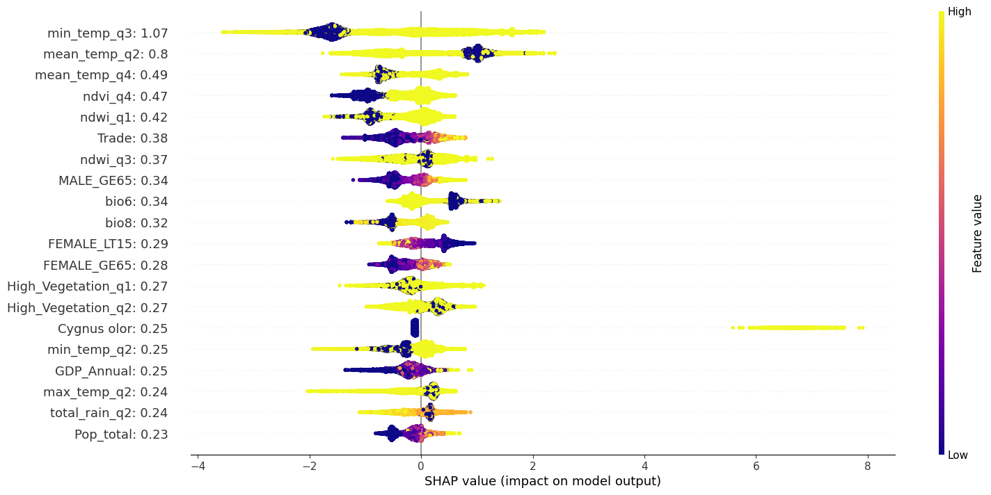

Figure 3:Summary SHAP plot depicting the global as well as the local feature impact on model 2. Temperature, normalized deviation vegetation index, and normalized deviation water index emerge as the top ranking features. Bio6 and wild positively pushes the prediction of the outbreaks with Cygnus olor being the leading species. Low bio6 (temperature seasonality), mean_temp_q2 values has positive impact on the model (+ve predictions). On the other hand, reduction in water and vegetation in Q4 and Q1 respectively together with low values in min_temp_q3 has negative impact on the model (-ve prediction).

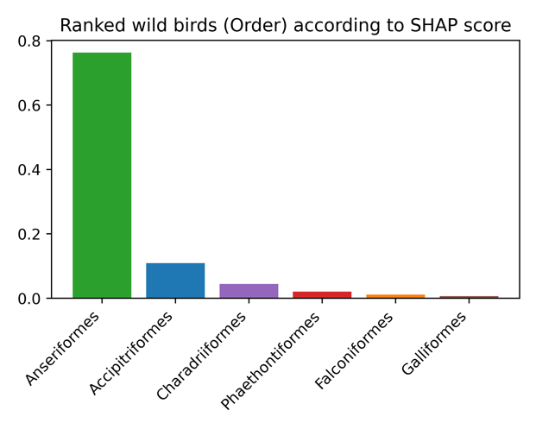

Figure 4: Specific order ranking of wild birds as predicted by M2

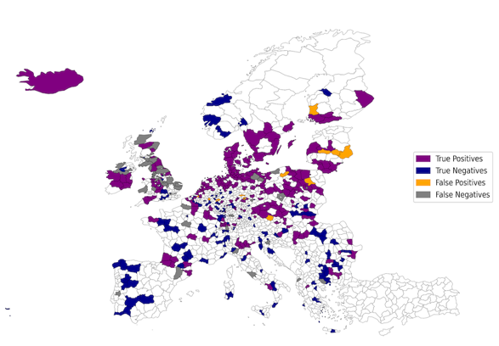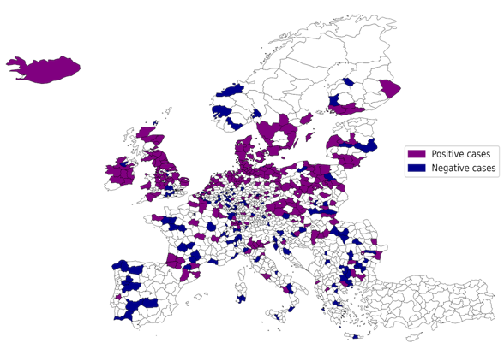

Figure 5: Test dataset labeled positive and negative used in testing the model on data from 2021 (Left). Predicted AIV cases binned into True positives (Actual positive cases predicted), True negatives (Actual negative cases predicted), False positives (Negative cases predicted as positives) and False negatives (Positive cases predicted as negatives) to the right based on the test data from 2021.

**Feature interactions**

Among the bird’s species, *Cygnus olor, belonging to the family* Anatidae and Order Anseriformeshas the highest local impact with the largest positive SHAP value on a subset of the models’ data. Accipitriformes and birds of unknown species within the family Anatidae (Order Anseriformes) as well as the Laridae (Charadriiformes) rank second and third respectively according to the SHAP scores (*Figure 4*). Bi-variate interaction analysis indicates that in the model prediction the observation of infected Cygnus olor interacts with the temperature seasonality bioclima (bio4) variable (*Figure SI 4*) when predicting poultry outbreak events, while Anatidae and Anserinae interacts with the male and female population with ages greater than 65 respectively.

# **Discussion**

AIV are not only a threat to food safety and bird welfare but also to human health. The ability of AIV to cross the species barrier and to infect humans raises concerns about their epidemic and pandemic potential. Our investigation focused on studying the drivers and predicting the dynamics of the spread from wild birds to poultry. Such events can be indicative of human spillover as poultry are domesticated and in close contact with humans. Public health measures to prevent the spread of AIV rely on monitoring and surveillance of wild and domestic birds.22 It entails monitoring sentinel birds in the wild or in a commercial poultry flock, diagnostic testing, and surveillance of flock mortality and morbidity.42,43 AIV detection can then trigger a range of containment efforts, including enhanced biosecurity at poultry farms, movement ban, vaccination and culling of the entire flock, to prevent dispersion to other flocks.44,45 The enactment of these measures often depends on the timing of the alert which in turn depends on the sensitivity of the surveillance system.

Our findings elucidate the contextual determinants of AIV transmission in Europe and rank the importance of specific drivers of the reported AIV outbreaks analyzed in this study. We define the climatic and environmental conditions under which these outbreaks occur, namely the colder temperatures in the Fall and the importance of vegetation and water features. We also disentangle the contribution of wild birds to AIV outbreaks and other socioeconomic determinants, such as trade. These findings are important in light of AIV surveillance efforts that often lack sensitivity and specificity. Our findings can help target sentinel surveillance to improve the ascertainment proportion of cases and advance early warning systems for AIV outbreaks.

The three most important variables that positively impact our models’ prediction are the wild birds, climate (bio6), and environment (water and vegetation indices) (See *Figure 3*). This relationship reveals key drivers of AIV outbreaks as predicted by our model. *Cygnus olor* emerges as the main species with a strong positive impact. The lowest temperature of the coldest month (bio6) also has a positive impact on the predictions, where low values result in higher AIV outbreak predictions. Indeed, AIVs tend to survive longer in colder ambient conditions, as lower temperatures facilitate their viability outside the host.46 This might be one of the reasons why most AIV outbreaks have been historically reported during the winter season in the Global North. Conversely, an increase in the maximum temperature in quarter two negatively impacts the prediction. In quarter one, a decrease in the water index results in a low likelihood of outbreaks while an increase is observed in the second quarter. A similar effect is observed for the normalized vegetation index (NDVI) in quarter four where low vegetation index results in low prediction rates. This model therefore suggests that AIV outbreaks seem to be driven by temperature changes between the first and the second quarters of the year when migrating birds gather at environmental sites, and increase their contact rates, possibly during feeding, mating or communal roosts. Thus, for most datapoints, AIV outbreaks occur at low temperatures in the first and second quarters of the year.

*Cygnus olor*, the main bird species implicated in AIV outbreaks in our model, interacts with temperature seasonality (bio4), a bioclimatic variable (See Supplementary Information). Since bio4 is known to span several years, the influence of *Cygnus olor* seems to cut across the four quarters as temperatures vary. Coupled with the above findings, our results highlight the intricate interplay between wild birds, climate, and environment. Previously, it has been argued that AIV spread was mainly due to human and trade activities dismissing the role of wild birds. However, wild birds have been implicated in the spread of AIV in remote areas.47 HPAIV infections with H5N1 among Mortalities in Mute (*Cygnus olor*) have been documented in Germany in part due to their large size and ease of identification.48 The reporting region, known to be a temporary resting site for migratory birds, further highlights the importance of congregation at certain sites.

Highly pathogenic AIV (HPAIV) outbreaks in remote areas tend to be considered rare events since normal occurrences are restricted to areas adjacent to poultry farms. Indeed, it has been found that HPAIV wild bird reporting increases in the vicinity of poultry farms. This is due to genetic proximity to domesticated poultry which pose a wider risk of infections. *Beerens etal* details the genetic traits of wild birds suspected to introduce several poultry H5N6 infections in the Netherlands with *Cygnus Olor* and *Anatidae* being among the culprits.49 Specifically, the genetic analysis showed that poultry outbreaks were traced to contact with wild birds rather than poultry-to-poultry transmission. A great deal of these cases has been concluded to be caused by biological and ecological factors. Other studies have also used epidemiologic and genetic data to disentangle transmission dynamics of HPAIV.50

A counter threat to wild birds from poultry infections has also been reported in literature. Proximity to poultry as well as humans often leads to such significant infection spikes posing existential threats to local biodiversity.51 These glaring facts call for the need to build pandemic preparedness tools and early warning systems. Strengthening both active and passive surveillance systems by collecting and analyzing data to mitigate risks is one approach.52 Another method would involve simulation and modeling of existing data to predict outbreaks. In both cases, high success rates depend on reliable strategies to collate data regarding the susceptible wild bird populations, a task that is always difficult to achieve.53

We believe that this current work takes a step towards achieving this mean feat. Using a high-resolution dataset and robust models, we identify important nexus contributing to AIV outbreaks. Our model delineates the climatic, environmental, socioeconomic and biotic conditions that favor AIV outbreaks. These insights can inform the timing and geographic expanse of active or passive surveillance of wild birds and poultry flocks.22 It can direct the spatiotemporal extent of environmental sampling54 and citizen science55 initiatives to advance the sensitivity of AIV surveillance. The combination of our modelling approach with targeted data collection can further map high risk areas and periods of the year that are prone to AIV outbreaks. Such continuous data collection ensures accurate capturing of complex information enabling quick interventions whenever outbreaks arise.

# **Limitation and Outlook**

We present here a base model which identified the main drivers of AIV outbreaks in Europe. However, there exist some shortcomings of our model. The dataset does not differentiate between the different surveillance systems that are employed in European countries. It does not account for differences in AIV detection strategies, sample collection efforts, or intervention measures. Moreover, the model does not exhaustively highlight the complexity of AIV viral sharing between wild birds and poultry, as they are not equally susceptible to infection. Domesticated birds are likely to be more at risk of infection from wild birds than the reverse. Factors such as virus clades have not been captured in the model.

Recently, there have been reported sporadic human AIV events which are thought to originate from low AIV pathogenic pathways. A more complete picture can be achieved by overlaying existing animal AIV data with human AIV data to identify existential threats of avian outbreaks and consequent mitigation strategies. Utilization of the so-called hybrid models (a combination of ML models with physics aware models) to investigate dynamic roles played by additional variables such as wind speed may also contribute towards understanding the animal-human disease interface.

# **Conclusion**

In this work, we have provided the key drivers of AIV outbreaks at the European NUTS3 level. Supervised machine learning as implemented in the XGBoost software package generated the base model with high predictive ability. For the interpretation we used a game theory engine, which provides an easy way to explain the underlying complexity of the predictors.

Specifically, wild birds, climate and environment are predicted to be the key drivers of AIV outbreaks in Europe. These three drivers serve as main indicators that can aid in identifying patterns from animal data for continual monitoring of potential AIV outbreaks. The key climate indicators implicated in driving AIV outbreaks are the temperature of the coldest month, the mean temperature of quarter two and the minimum temperature of quarter three. Water (quarter one) and vegetation (quarter two) indices also play a critical role. Wild birds, especially *Cygnus olor* have the highest impact on our model, a finding that resonates with literature reports.

This work has therefore highlighted various patterns and variables that can be used for sentinel surveillance to monitor AIV outbreaks and for creating early warning systems.

Our work lays a foundation in the quest to integrate animal, human, and eco-climate data to create pandemic preparedness systems. Such complex data could help in creating strong surveillance tools to capture potential risks posed by changing climate patterns, wild bird migratory patterns and re-infection cases. Additionally, complex methods of collating data as well as continuous analysis would result in reliable risk assessments and foresightful policy developments.

# **Data Availability**

The data used in this study is available on request from the corresponding author.

**Acknowledgements**

Joacim Rocklöv received support from the Alexander von Humboldt Foundation.

This work was partly funded within the framework of the Horizon Europe program through the project IDAlert (https://idalertproject.eu) with grant no. 101057554.

The team is grateful to WAHIS for the provision of data.

# **References**

(1) Hippocrates; Burnell, A. C.; Littré, E.; Linden, J. A. van der; Cornarius, J.; Adams, F.; Royal College of Physicians of London. *Hippocrates on Airs, Waters and Places*; London : Wyman & Sons, 1881.

(2) Li, J.; Lai, S.; Gao, G. F.; Shi, W. The Emergence, Genomic Diversity and Global Spread of SARS-CoV-2. *Nature* **2021**, *600* (7889), 408–418. https://doi.org/10.1038/s41586-021-04188-6.

(3) Koopmans, M.; Wilbrink, B.; Conyn, M.; Natrop, G.; van der Nat, H.; Vennema, H.; Meijer, A.; van Steenbergen, J.; Fouchier, R.; Osterhaus, A.; Bosman, A. Transmission of H7N7 Avian Influenza A Virus to Human Beings during a Large Outbreak in Commercial Poultry Farms in the Netherlands. *The Lancet* **2004**, *363* (9409), 587–593. https://doi.org/10.1016/S0140-6736(04)15589-X.

(4) Lindh, E.; Lounela, H.; Ikonen, N.; Kantala, T.; Savolainen-Kopra, C.; Kauppinen, A.; Österlund, P.; Kareinen, L.; Katz, A.; Nokireki, T.; Jalava, J.; London, L.; Pitkäpaasi, M.; Vuolle, J.; Punto-Luoma, A.-L.; Kaarto, R.; Voutilainen, L.; Holopainen, R.; Kalin-Mänttäri, L.; Laaksonen, T.; Kiviranta, H.; Pennanen, A.; Helve, O.; Laamanen, I.; Melin, M.; Tammiranta, N.; Rimhanen-Finne, R.; Gadd, T.; Salminen, M. Highly Pathogenic Avian Influenza A(H5N1) Virus Infection on Multiple Fur Farms in the South and Central Ostrobothnia Regions of Finland, July 2023. *Euro Surveill. Bull. Eur. Sur Mal. Transm. Eur. Commun. Dis. Bull.* **2023**, *28* (31), 2300400. https://doi.org/10.2807/1560-7917.ES.2023.28.31.2300400.

(5) Agüero, M.; Monne, I.; Sánchez, A.; Zecchin, B.; Fusaro, A.; Ruano, M. J.; Del Valle Arrojo, M.; Fernández-Antonio, R.; Souto, A. M.; Tordable, P.; Cañás, J.; Bonfante, F.; Giussani, E.; Terregino, C.; Orejas, J. J. Highly Pathogenic Avian Influenza A(H5N1) Virus Infection in Farmed Minks, Spain, October 2022. *Euro Surveill. Bull. Eur. Sur Mal. Transm. Eur. Commun. Dis. Bull.* **2023**, *28* (3), 2300001. https://doi.org/10.2807/1560-7917.ES.2023.28.3.2300001.

(6) Imai, M.; Watanabe, T.; Hatta, M.; Das, S. C.; Ozawa, M.; Shinya, K.; Zhong, G.; Hanson, A.; Katsura, H.; Watanabe, S.; Li, C.; Kawakami, E.; Yamada, S.; Kiso, M.; Suzuki, Y.; Maher, E. A.; Neumann, G.; Kawaoka, Y. Experimental Adaptation of an Influenza H5 Haemagglutinin (HA) Confers Respiratory Droplet Transmission to a Reassortant H5 HA/H1N1 Virus in Ferrets. *Nature* **2012**, *486* (7403), 420–428. https://doi.org/10.1038/nature10831.

(7) Ferguson, N. M.; Fraser, C.; Donnelly, C. A.; Ghani, A. C.; Anderson, R. M. Public Health Risk from the Avian H5N1 Influenza Epidemic. *Science* **2004**, *304* (5673), 968–969. https://doi.org/10.1126/science.1096898.

(8) Pinto, R. M.; Bakshi, S.; Lytras, S.; Zakaria, M. K.; Swingler, S.; Worrell, J. C.; Herder, V.; Hargrave, K. E.; Varjak, M.; Cameron-Ruiz, N.; Collados Rodriguez, M.; Varela, M.; Wickenhagen, A.; Loney, C.; Pei, Y.; Hughes, J.; Valette, E.; Turnbull, M. L.; Furnon, W.; Gu, Q.; Orr, L.; Taggart, A.; Diebold, O.; Davis, C.; Boutell, C.; Grey, F.; Hutchinson, E.; Digard, P.; Monne, I.; Wootton, S. K.; MacLeod, M. K. L.; Wilson, S. J.; Palmarini, M. BTN3A3 Evasion Promotes the Zoonotic Potential of Influenza A Viruses. *Nature* **2023**, *619* (7969), 338–347. https://doi.org/10.1038/s41586-023-06261-8.

(9) cdc. *Technical Report: Highly Pathogenic Avian Influenza A(H5N1) Viruses*. Centers for Disease Control and Prevention. https://www.cdc.gov/flu/avianflu/spotlights/2022-2023/h5n1-technical-report_june.htm (accessed 2023-08-10).

(10) Krammer, F.; Smith, G. J. D.; Fouchier, R. A. M.; Peiris, M.; Kedzierska, K.; Doherty, P. C.; Palese, P.; Shaw, M. L.; Treanor, J.; Webster, R. G.; García-Sastre, A. Influenza. *Nat. Rev. Dis. Primer* **2018**, *4* (1), 1–21. https://doi.org/10.1038/s41572-018-0002-y.

(11) European Food Safety Authority, European Centre for Disease Prevention and Control, European Union Reference Laboratory for Avian Influenza; Adlhoch, C.; Fusaro, A.; Gonzales, J. L.; Kuiken, T.; Mirinaviciute, G.; Niqueux, É.; Stahl, K.; Staubach, C.; Terregino, C.; Broglia, A.; Kohnle, L.; Baldinelli, F. Avian Influenza Overview March – April 2023. *EFSA J.* **2023**, *21* (6), e08039. https://doi.org/10.2903/j.efsa.2023.8039.

(12) Fergus, R.; Fry, M.; Karesh, W. B.; Marra, P. P.; Newman, S.; Paul, E. Migratory Birds and Avian Flu. *Science* **2006**, *312* (5775), 845–846. https://doi.org/10.1126/science.312.5775.845c.

(13) Moreno, A.; Bonfante, F.; Bortolami, A.; Cassaniti, I.; Caruana, A.; Cottini, V.; Cereda, D.; Farioli, M.; Fusaro, A.; Lavazza, A.; Lecchini, P.; Lelli, D.; Maroni Ponti, A.; Nassuato, C.; Pastori, A.; Rovida, F.; Ruocco, L.; Sordilli, M.; Baldanti, F.; Terregino, C. Asymptomatic Infection with Clade 2.3.4.4b Highly Pathogenic Avian Influenza A(H5N1) in Carnivore Pets, Italy, April 2023. *Eurosurveillance* **2023**, *28* (35), 2300441. https://doi.org/10.2807/1560-7917.ES.2023.28.35.2300441.

(14) Briand, F.-X.; Souchaud, F.; Pierre, I.; Beven, V.; Hirchaud, E.; Hérault, F.; Planel, R.; Rigaudeau, A.; Bernard-Stoecklin, S.; Van der Werf, S.; Lina, B.; Gerbier, G.; Eterradossi, N.; Schmitz, A.; Niqueux, E.; Grasland, B. Highly Pathogenic Avian Influenza A(H5N1) Clade 2.3.4.4b Virus in Domestic Cat, France, 2022. *Emerg. Infect. Dis.* **2023**, *29* (8), 1696–1698. https://doi.org/10.3201/eid2908.230188.

(15) Sillman, S. J.; Drozd, M.; Loy, D.; Harris, S. P. Naturally Occurring Highly Pathogenic Avian Influenza Virus H5N1 Clade 2.3.4.4b Infection in Three Domestic Cats in North America during 2023. *J. Comp. Pathol.* **2023**, *205*, 17–23. https://doi.org/10.1016/j.jcpa.2023.07.001.

(16) Domańska-Blicharz, K.; Świętoń, E.; Świątalska, A.; Monne, I.; Fusaro, A.; Tarasiuk, K.; Wyrostek, K.; Styś-Fijoł, N.; Giza, A.; Pietruk, M.; Zechchin, B.; Pastori, A.; Adaszek, Ł.; Pomorska-Mól, M.; Tomczyk, G.; Terregino, C.; Winiarczyk, S. Outbreak of Highly Pathogenic Avian Influenza A(H5N1) Clade 2.3.4.4b Virus in Cats, Poland, June to July 2023. *Eurosurveillance* **2023**, *28* (31), 2300366. https://doi.org/10.2807/1560-7917.ES.2023.28.31.2300366.

(17) Songserm, T.; Amonsin, A.; Jam-on, R.; Sae-Heng, N.; Meemak, N.; Pariyothorn, N.; Payungporn, S.; Theamboonlers, A.; Poovorawan, Y. Avian Influenza H5N1 in Naturally Infected Domestic Cat. *Emerg. Infect. Dis.* **2006**, *12* (4), 681–683. https://doi.org/10.3201/eid1204.051396.

(18) Keawcharoen, J.; Oraveerakul, K.; Kuiken, T.; Fouchier, R. A. M.; Amonsin, A.; Payungporn, S.; Noppornpanth, S.; Wattanodorn, S.; Theamboonlers, A.; Tantilertcharoen, R.; Pattanarangsan, R.; Arya, N.; Ratanakorn, P.; Osterhaus, A. D. M. E.; Poovorawan, Y. Avian Influenza H5N1 in Tigers and Leopards. *Emerg. Infect. Dis.* **2004**, *10* (12), 2189–2191. https://doi.org/10.3201/eid1012.040759.

(19) Lipsitch, M.; Barclay, W.; Raman, R.; Russell, C. J.; Belser, J. A.; Cobey, S.; Kasson, P. M.; Lloyd-Smith, J. O.; Maurer-Stroh, S.; Riley, S.; Beauchemin, C. A.; Bedford, T.; Friedrich, T. C.; Handel, A.; Herfst, S.; Murcia, P. R.; Roche, B.; Wilke, C. O.; Russell, C. A. Viral Factors in Influenza Pandemic Risk Assessment. *eLife* **2016**, *5*, e18491. https://doi.org/10.7554/eLife.18491.

(20) WAHIS. *World Animal Health Information Sytem*. WOAH - World Organisation for Animal Health. https://www.woah.org/en/home/ (accessed 2023-08-14).

(21) Morin, C. W.; Semenza, J. C.; Trtanj, J. M.; Glass, G. E.; Boyer, C.; Ebi, K. L. Unexplored Opportunities: Use of Climate- and Weather-Driven Early Warning Systems to Reduce the Burden of Infectious Diseases. *Curr. Environ. Health Rep.* **2018**, *5* (4), 430–438. https://doi.org/10.1007/s40572-018-0221-0.

(22) Kjær, L. J.; Hjulsager, C. K.; Larsen, L. E.; Boklund, A. E.; Halasa, T.; Ward, M. P.; Kirkeby, C. T. Landscape Effects and Spatial Patterns of Avian Influenza Virus in Danish Wild Birds, 2006–2020. *Transbound. Emerg. Dis.* **2022**, *69* (2), 706–719. https://doi.org/10.1111/tbed.14040.

(23) Jung Kjær, L.; Ward, M. P.; Boklund, A. E.; Larsen, L. E.; Hjulsager, C. K.; Kirkeby, C. T. Using Surveillance Data for Early Warning Modelling of Highly Pathogenic Avian Influenza in Europe Reveals a Seasonal Shift in Transmission, 2016-2022. *Sci. Rep.* **2023**, *13* (1), 15396. https://doi.org/10.1038/s41598-023-42660-7.

(24) Ward, M. P.; Maftei, D. N.; Apostu, C. L.; Suru, A. R. Association between Outbreaks of Highly Pathogenic Avian Influenza Subtype H5N1 and Migratory Waterfowl (Family Anatidae) Populations. *Zoonoses Public Health* **2009**, *56* (1), 1–9. https://doi.org/10.1111/j.1863-2378.2008.01150.x.

(25) Belkhiria, J.; Hijmans, R. J.; Boyce, W.; Crossley, B. M.; Martínez-López, B. Identification of High Risk Areas for Avian Influenza Outbreaks in California Using Disease Distribution Models. *PloS One* **2018**, *13* (1), e0190824. https://doi.org/10.1371/journal.pone.0190824.

(26) Walsh, M. G.; Amstislavski, P.; Greene, A.; Haseeb, M. A. The Landscape Epidemiology of Seasonal Clustering of Highly Pathogenic Avian Influenza (H5N1) in Domestic Poultry in Africa, Europe and Asia. *Transbound. Emerg. Dis.* **2017**, *64* (5), 1465–1478. https://doi.org/10.1111/tbed.12537.

(27) Schreuder, J.; de Knegt, H. J.; Velkers, F. C.; Elbers, A. R. W.; Stahl, J.; Slaterus, R.; Stegeman, J. A.; de Boer, W. F. Wild Bird Densities and Landscape Variables Predict Spatial Patterns in HPAI Outbreak Risk across The Netherlands. *Pathog. Basel Switz.* **2022**, *11* (5), 549. https://doi.org/10.3390/pathogens11050549.

(28) Hunter, P. Europe’s Worst Ever Bird Flu Outbreak. *EMBO Rep.* **2022**, *23* (10), e56048. https://doi.org/10.15252/embr.202256048.

(29) Guinat, C.; Valenzuela Agüí, C.; Vaughan, T. G.; Scire, J.; Pohlmann, A.; Staubach, C.; King, J.; Świętoń, E.; Dán, Á.; Černíková, L.; Ducatez, M. F.; Stadler, T. Disentangling the Role of Poultry Farms and Wild Birds in the Spread of Highly Pathogenic Avian Influenza Virus in Europe. *Virus Evol.* **2022**, *8* (2), veac073. https://doi.org/10.1093/ve/veac073.

(30) Bergervoet, S. A.; Ho, C. K. Y.; Heutink, R.; Bossers, A.; Beerens, N. Spread of Highly Pathogenic Avian Influenza (HPAI) H5N5 Viruses in Europe in 2016–2017 Appears Related to the Timing of Reassortment Events. *Viruses* **2019**, *11* (6), 501. https://doi.org/10.3390/v11060501.

(31) Verhagen, J. H.; Fouchier, R. A. M.; Lewis, N. Highly Pathogenic Avian Influenza Viruses at the Wild–Domestic Bird Interface in Europe: Future Directions for Research and Surveillance. *Viruses* **2021**, *13* (2), 212. https://doi.org/10.3390/v13020212.

(32) Chander, G.; Markham, B. L.; Helder, D. L. Summary of Current Radiometric Calibration Coefficients for Landsat MSS, TM, ETM+, and EO-1 ALI Sensors. *Remote Sens. Environ.* **2009**, *113* (5), 893–903. https://doi.org/10.1016/j.rse.2009.01.007.

(33) Didan, Kamel. MODIS/Terra Vegetation Indices 16-Day L3 Global 250m SIN Grid V061, 2021. https://doi.org/10.5067/MODIS/MOD13Q1.061.

(34) Aybar, C.; Wu, Q.; Bautista, L.; Yali, R.; Barja, A. Rgee: An R Package for Interacting with Google Earth Engine. *J. Open Source Softw.* **2020**, *5* (51), 2272. https://doi.org/10.21105/joss.02272.

(35) Gorelick, N.; Hancher, M.; Dixon, M.; Ilyushchenko, S.; Thau, D.; Moore, R. Google Earth Engine: Planetary-Scale Geospatial Analysis for Everyone. *Remote Sens. Environ.* **2017**, *202*, 18–27. https://doi.org/10.1016/j.rse.2017.06.031.

(36) European Commission. Statistical Office of the European Union. *EU Legislation on the 2021 Population and Housing Censuses: Explanatory Notes : 2019 Edition.*; Publications Office: LU, 2019.

(37) Fick, S. E.; Hijmans, R. J. WorldClim 2: New 1-Km Spatial Resolution Climate Surfaces for Global Land Areas. *Int. J. Climatol.* **2017**, *37* (12), 4302–4315. https://doi.org/10.1002/joc.5086.

(38) Manaswi, N. K. *Deep Learning with Applications Using Python: Chatbots and Face, Object, and Speech Recognition With TensorFlow and Keras*, 1st ed. 2018.; Apress : Imprint: Apress: Berkeley, CA, 2018. https://doi.org/10.1007/978-1-4842-3516-4.

(39) Ribeiro, M. T.; Singh, S.; Guestrin, C. “Why Should I Trust You?”: Explaining the Predictions of Any Classifier. arXiv August 9, 2016. https://doi.org/10.48550/arXiv.1602.04938.

(40) Lundberg, S.; Lee, S.-I. A Unified Approach to Interpreting Model Predictions. arXiv November 24, 2017. https://doi.org/10.48550/arXiv.1705.07874.

(41) Vandegrift, K. J.; Sokolow, S. H.; Daszak, P.; Kilpatrick, A. M. Ecology of Avian Influenza Viruses in a Changing World. *Ann. N. Y. Acad. Sci.* **2010**, *1195* (1), 113–128. https://doi.org/10.1111/j.1749-6632.2010.05451.x.

(42) Comin, A.; Stegeman, A.; Marangon, S.; Klinkenberg, D. Evaluating Surveillance Strategies for the Early Detection of Low Pathogenicity Avian Influenza Infections. *PLOS ONE* **2012**, *7* (4), e35956. https://doi.org/10.1371/journal.pone.0035956.

(43) Beltrán-Alcrudo, D.; Carpenter, T. E.; Cardona, C. A Flock-Tailored Early Warning System for Low Pathogenic Avian Influenza (LPAI) in Commercial Egg Laying Flocks. *Prev. Vet. Med.* **2009**, *92* (4), 324–332. https://doi.org/10.1016/j.prevetmed.2009.07.013.

(44) Guinat, C.; Agui, C. V.; Vaughan, T. G.; Scire, J.; Pohlmann, A.; Staubach, C.; King, J.; Swieton, E.; Dan, A.; Cernikova, L.; Ducatez, M. F.; Stadler, T. Disentangling the Role of Poultry Farms and Wild Birds in the Spread of Highly Pathogenic Avian Influenza Virus H5N8 in Europe. bioRxiv October 24, 2021, p 2021.10.22.465255. https://doi.org/10.1101/2021.10.22.465255.

(45) Śmietanka, K.; Świętoń, E.; Wyrostek, K.; Kozak, E.; Tarasiuk, K.; Styś-Fijoł, N.; Dziadek, K.; Niemczuk, K. Highly Pathogenic Avian Influenza H5Nx in Poland in 2020/2021: A Descriptive Epidemiological Study of a Large-Scale Epidemic. *J. Vet. Res.* **2022**, *66* (1), 1–7. https://doi.org/10.2478/jvetres-2022-0017.

(46) Martin, G.; Becker, D. J.; Plowright, R. K. Environmental Persistence of Influenza H5N1 Is Driven by Temperature and Salinity: Insights From a Bayesian Meta-Analysis. *Front. Ecol. Evol.* **2018**, *6*.

(47) Normile, D. Are Wild Birds to Blame? *Science* **2005**, *310* (5747), 426–428. https://doi.org/10.1126/science.310.5747.426.

(48) Teifke, J. P.; Klopfleisch, R.; Globig, A.; Starick, E.; Hoffmann, B.; Wolf, P. U.; Beer, M.; Mettenleiter, T. C.; Harder, T. C. Pathology of Natural Infections by H5N1 Highly Pathogenic Avian Influenza Virus in Mute (Cygnus Olor) and Whooper (Cygnus Cygnus) Swans. *Vet. Pathol.* **2007**, *44* (2), 137–143. https://doi.org/10.1354/vp.44-2-137.

(49) Beerens, N.; Heutink, R.; Pritz-Verschuren, S.; Germeraad, E. A.; Bergervoet, S. A.; Harders, F.; Bossers, A.; Koch, G. Genetic Relationship between Poultry and Wild Bird Viruses during the Highly Pathogenic Avian Influenza H5N6 Epidemic in the Netherlands, 2017–2018. *Transbound. Emerg. Dis.* **2019**, *66* (3), 1370–1378. https://doi.org/10.1111/tbed.13169.

(50) Mulatti, P.; Fusaro, A.; Scolamacchia, F.; Zecchin, B.; Azzolini, A.; Zamperin, G.; Terregino, C.; Cunial, G.; Monne, I.; Marangon, S. Integration of Genetic and Epidemiological Data to Infer H5N8 HPAI Virus Transmission Dynamics during the 2016-2017 Epidemic in Italy. *Sci. Rep.* **2018**, *8* (1), 18037. https://doi.org/10.1038/s41598-018-36892-1.

(51) Klaassen, M.; Wille, M. The Plight and Role of Wild Birds in the Current Bird Flu Panzootic. *Nat. Ecol. Evol.* **2023**, 1–2. https://doi.org/10.1038/s41559-023-02182-x.

(52) Peiris, J. S. M.; Poon, L. L. M.; Guan, Y. Surveillance of Animal Influenza for Pandemic Preparedness. *Science* **2012**, *335* (6073), 1173–1174. https://doi.org/10.1126/science.1219936.

(53) Iglesias, I.; Perez, A. M.; De la Torre, A.; Muñoz, M. J.; Martínez, M.; Sánchez-Vizcaíno, J. M. Identifying Areas for Infectious Animal Disease Surveillance in the Absence of Population Data: Highly Pathogenic Avian Influenza in Wild Bird Populations of Europe. *Prev. Vet. Med.* **2010**, *96* (1), 1–8. https://doi.org/10.1016/j.prevetmed.2010.05.002.

(54) Hood, G.; Roche, X.; Brioudes, A.; von Dobschuetz, S.; Fasina, F. O.; Kalpravidh, W.; Makonnen, Y.; Lubroth, J.; Sims, L. A Literature Review of the Use of Environmental Sampling in the Surveillance of Avian Influenza Viruses. *Transbound. Emerg. Dis.* **2021**, *68* (1), 110–126. https://doi.org/10.1111/tbed.13633.

(55) Saavedra, I.; Rabadán-González, J.; Aragonés, D.; Figuerola, J. Can Citizen Science Contribute to Avian Influenza Surveillance? *Pathogens* **2023**, *12* (9), 1183. https://doi.org/10.3390/pathogens12091183.